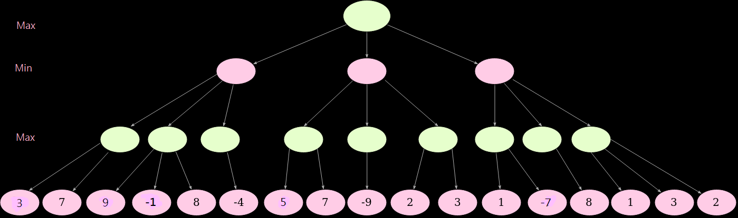

1. 〔初始化〕假設Max α=-∞, min β=+∞
2. Max(3,7)=7

